KidzCoding Hour of Code - Wardrobe

Activity:

This activity is a **simple** wardrobe game in **Scratch** that uses **loops, conditionals,** and **user input.** This game will allow the player to change the **size** and **color** of their sprite.

Learning Objectives:

* Learn how to change color
* Learn how to change size
* Learn how to assign actions to keybinds
* Learn how to duplicate code for efficiency

Materials:

* Finished project: <https://scratch.mit.edu/projects/876904996>
* Starter project: default scratch project

Coding Time!

Step one: Choosing a sprite and laying the foundation of your code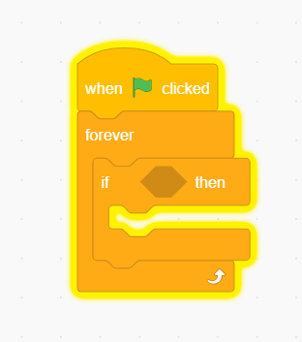

* **First, delete the default sprite and choose a sprite of your choice**
* **Then, add “when started” block and a forever loop**

Step two: adding the if-then statement and duplicating 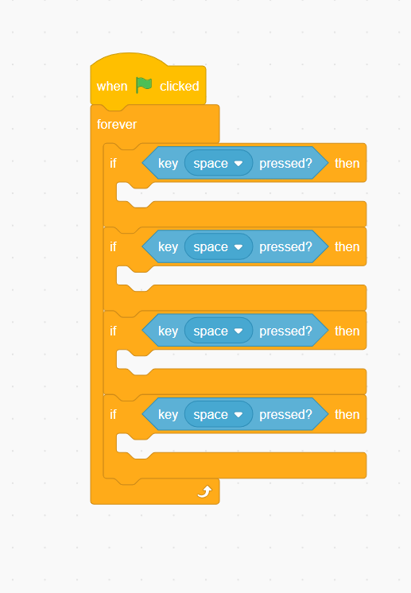

* **First, add an if statement to the inside of the forever loop**
* **Add the “key pressed” block to the if then statement**
* **Then, duplicate the if statement three times so you have four of them in total**

Step three: creating the first two keyboard functions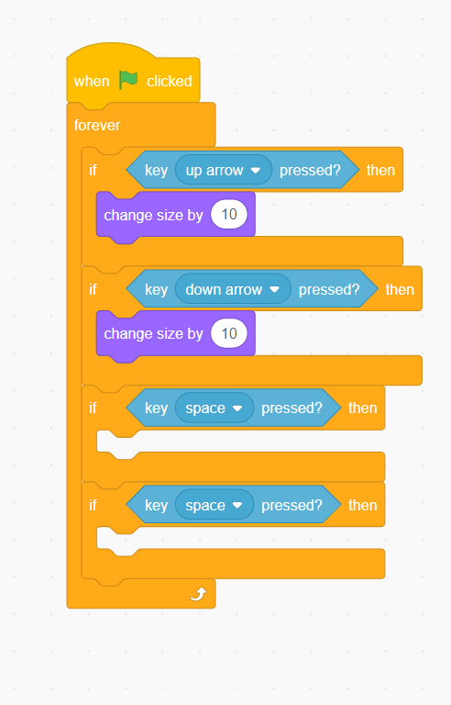

* **First, set the first key pressed statement to up arrow**
* **Then set the second one to down arrow**
* **In the if statement of the first add the change size block**
* **Add another change size block to the second if statement. But for this one, make it -10**
* **Now you can make your sprite larger and smaller**

Step four: creating the last two keyboard functions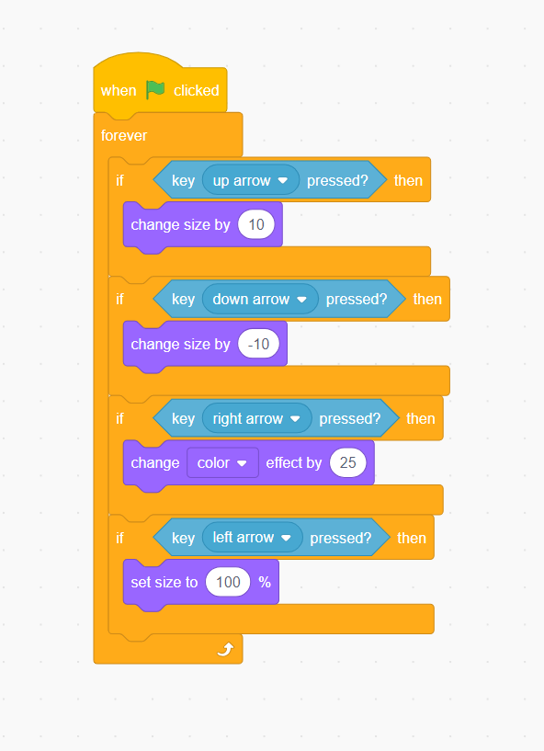

* **First, set the third key pressed statement to the right arrow and the fourth one to the left arrow**
* **Next, add the “change color effect” statement to the third if statement**
* **Then, add the “set size” function to the fourth if statement**
* **Now you can reset the size of your sprite and change its color**

Congratulations, you have just completed an Hour of Code!

Feel free to mess around with the code to make it suitable for your intentions